A
Project Report on

“Hospital Dataset”
Submitted at
Fortune Cloud Technology, Pune

Submitted by:
Gauri Arun Pise

Email:
gauripise190@gmail.com

Guided by:
Varsha Patil

Technology Used:
Microsoft Excel
Microsoft Power BI
Tableau Public Edition

Batch:
6th Jan,2025

: ˙ . Project Report: Spotify Dataset

INDEX

Section | Title
1 | Project Title
2 | Objective
3 | Tools & Technologies Used
4 | Insights (Chart by chart)
5 | Screenshots
6 | Challenges Faced
7 | Conclusion
7 | Future Scope

1)Project Title: Hospital Dashboard

2)Objective:
The objective of this Hospital Dashboard is to consolidate and visualize key healthcare data to monitor hospital performance, track patient flow, analyze departmental efficiency, and optimize resource utilization. By presenting real-time insights into admissions, discharges, bed occupancy, and treatment statistics, the dashboard enables hospital administrators and medical staff to make informed, data-driven decisions that enhance patient care, operational efficiency, and overall hospital management.

3)Tools and Technologies :
From above dataset I have created three dashboards in which I used three tools :
a)Microsoft Excel
b)Microsoft Power BI
c)Tableau Public Edition

4)Insights: Chart-by-chart analysis

A)Excel:

1)Chart Type: Column chart
Insight: Patients by department.
Minimum count of patients : 14135 and Department : Cardiology
Maximum count of patients : 14438 and Department : Oncology

2) Chart Type : Bar chart
Insight: Total cost by department
Minimum cost : 1426710213 and Department : Pediatrics
Maximum cost : 1452499162 and Department : Oncology

3) Chart Type: 100% stacked column
Insight: Gender distribution per department
Male: Minimum patient count : 4742 and Department : Pediatrics
Male: Maximum patient count : 4875 and Department : Oncology
Female: Minimum patient count : 4667 and Department : Cardiology
Female: Maximum patient count : 4824 and Department : Oncology
Other: Minimum patient count : 4705 and Department : Cardiology
Other: Maximum patient count : 4783 and Department : Neurology

4) Chart Type: Column chart
Insight: Patient count by month
Minimum patient : 7942 and Month : Feb
Maximum patient: 8613 and Month: Mar

5) Chart Type: Line chart
Insight: Monthly discharge trend
Minimum count of patient: 7737 and Month :Feb
Maximum count of patient : 8666 and Month : Mar

6) Chart Type: Pie chart
Insight: Blood type distribution
Minimum count of patient :12357 and Blood group : AB+
Maximum count of patient : 12610 and Blood group : B-

7) Chart Type: Column chart
Insight: Top 10 doctors with highest patient count
Minimum patient count: 27 and Doctor name: David Smith, James Johnson, Jessica Smith
Maximum Patient count: 42 and Doctor name: Michael Johnson

8) Chart Type: Pie Chart
Insight: Admission type distribution
Minimum patient count: 33244(33%) and Admission type: Elective
Maximum patient count: 33472(34%) and Admission type: Maternity

9) Chart Type: Clustered Column
Insight: Diagnosis wise patient distribution
Cancer minimum patient count: 4161 and Gender: Female
Cancer maximum patient count: 4209 and Gender: Other
Diabetes minimum patient count: 4021 and Gender: Female
Diabetes maximum patient count: 4226 and Gender: Other
Epilepsy minimum patient count: 4113 and Gender: Female
Epilepsy maximum patient count: 4160 and Gender: Other
Fracture minimum patient count: 4035 and Gender: Other
Fracture maximum patient count: 4288 and Gender: Male
Hypertension minimum patient count: 4130 and Gender: Other
Hypertension maximum patient count: 4194 and Gender: Female
Infection minimum patient count: 4156 and Gender: Female
Infection maximum patient count: 4196 and Gender: Male
Pregnancy minimum patient count: 4152 and Gender: Male
Pregnancy maximum patient count: 4197 and Gender: Female
Stroke minimum patient count: 4128 and Gender: Other
Stroke maximum patient count: 4235 and Gender: Female

10) Chart Type: Clustered Column
Insight: Department wise patient status
Pediatrics minimum patient count: 4709 and Status: Transferred
Pediatrics maximum patient count: 4787 and Status: Admitted
Orthopedic minimum patient count: 4727 and Status: Transferred
Orthopedic maximum patient count: 4822 and Status: Admitted
Oncology minimum patient count: 4750 and Status: Discharged
Oncology maximum patient count: 4932 and Status: Admitted
Neurology minimum patient count: 4726 and Status: Transferred
Neurology maximum patient count: 4906 and Status: Discharged
General Medicine minimum patient count: 4706 and Status: Admitted
General Medicine maximum patient count: 4780 and Status: Transferred
Emergency minimum patient count: 4742 and Status: Transferred
Emergency maximum patient count: 4795 and Status: Admitted
Cardiology minimum patient count: 4668 and Status: Transferred
Cardiology maximum patient count: 4809 and Status: Admitted

11) Chart Type: Pie Chart
Insight: Gender distribution
Minimum patient count: 33225(33%) and Gender: Other
Maximum patient count: 33496(34%) and Gender: Male

12) Chart Type: Line Chart
Insight: Admission wise patient count
Maternity minimum count: 2745 and Month: April
Maternity maximum count: 2887 and Month: May
Emergency minimum count: 2573 and Month: Feb
Emergency maximum count: 2881 and Month: March
Elective minimum count: 2606 and Month: Feb
Maternity minimum count: 2942 and Month: Dec

B)Microsoft Power Bi:
1) Chart Type: Bar chart
Insight: Patient by department
Minimum patient count :14135 and Department: Cardiology
Maximum patient count :14438 and Department: Oncology

2) Chart Type: Line chart
Insight: Admission trend by month
Minimum patient count :7942 and Month: February
Maximum patient count: 8613 and Month: March

3) Chart Type: Donut chart
Insight: Department wise amount paid
Minimum paid amount :$1.07 bn (14.15%) and Department: Pediatrics
Maximum paid amount: $1.09 bn (14.49%) and Department: Oncology

4) Chart Type: Stacked column chart
Insight: Procedure and lab tests count
Minimum procedure count :35233 and Department: Cardiology
Maximum procedure count:36454 and Department: Oncology
Minimum lab test count: 56563 and Department: Cardiology
Maximum lab test count: 58099 and Department: Oncology

5) Chart Type: Donut chart
Insight: Sum of total bill amount by gender
Minimum total bill amount: $3342322701.02(33.22%) and Gender: Other
Maximum total bill amount: $3362526462.45(33.42%) and Gender: Male

6) Chart Type: Clustered bar chart
Insight: Count of is prepaid id by diagnosis
Minimum count of is prepaid :12428 and Diagnosis: Diabetes
Maximum count of is prepaid :12572 and Diagnosis: Cancer

7) Chart Type: Donut chart
Insight: Gender Distribution
Minimum patient count: 33225(33.23%) and Gender: Other
Maximum patient count: 33496(33.5%) and Gender: Male

8) Chart Type: Stacked column chart
Insights: Average of length of stay by department
Minimum avg length of stay: 15.44 and Department: General Medicine
Maximum avg length of stay: 15.63 and Department: Emergency

9) Chart Type: Scatter Chart
Insights: Medical workload per patient
Minimum sum of procedure count: 35540 and Department: Pediatrics
Maximum sum of procedure count: 36155 and Department: General Medicine
Minimum sum of lab test count:56563 and Department: Cardiology
Maximum sum of lab test count: 57584 and Department: Neurology
Minimum medication count: 77634 and Department: Emergency
Maximum medication count: 78872 and Department: Neurology

10) Chart Type: Stacked bar chart
Insights: Top 10 highest paying patient
Minimum total bill amount: $199978.22 and Patient ID: P020662
Maximum total bill amount: $199995.58 and Patient ID: P098777

11) Chart Type: Donut chart
Insights: Count of patient id by payment mode
Minimum patient id count: 19800(19.8%) and Payment mode: Insurance
Maximum patient id count:20227(20.23%) and Payment mode: Credit Card

12) Chart Type: Area chart
Insights: Revenue trend over time
Minimum total bill amount: $26055396.5 , Payment mode: UPI and Month: 2023 June
Maximum total bill amount: $8889787.7 ,Payment mode: UPI and Month: 2024March
Minimum total bill amount: $28010789.7, Payment mode: Insurance and Month: 2023 June
Maximum total bill amount: $87917663.1Payment mode: Insurance and Month: 2024July
Minimum total bill amount: $28871163.55, Payment mode: Debit card and Month: 2023June
Maximum total bill amount: $91280772.51, Payment mode: Debit card and Month: 2024May
Minimum total bill amount: $29920354.85,Payment mode: Credit card and Month: 2023June
Maximum total bill amount: $91031329.65,Payment mode: Credit card and Month: 2023July
Minimum total bill amount: $30607193.55,Payment mode: Cash and Month: 2023June
Maximum total bill amount: $94900287.82,Payment mode: Cash and Month: 2023October

C) Tableau Public Edition

1) Chart Type: Line chart
Insight: Admission Trend
Minimum patient count :7942 and Month: February
Maximum patient count: 8613 and Month: March

2) Chart Type: Stacked bar chart
Insight: Patients by department
Minimum patient count :14135and Department: Cardiology
(Female: 4667, Male: 4763, Other: 4705)
Maximum patient count :14438 and Department: Oncology
(Female: 4824, Male:4875, Other:4739)

3) Chart Type: Pie chart
Insight: Payment mode distribution
Minimum amount paid: 1493146017 and Payment mode: Debit card
Maximum amount paid: 1528688250 and Payment mode: Credit card

4) Chart Type: Packed bubbles
Insight: Medication count analysis
Minimum medication count(bin): 0 and Count of medication : 10057
Maximum medication count(bin): 6 and Count of medication: 19771

5) Chart Type: Horizontal bar chart
Insight: Top 10 high-bill patients
Minimum bill amount: 199978.22 and Patient ID: P020662
Maximum bill amount: 199995.58 and Patient ID: P098777

6) Chart Type: Treemap chart
Insight: Top 10 insurance provider
Minimum outstanding amount: 2367925 and Insurance provider: Johnson Ltd
Maximum outstanding amount: 3068457 and Insurance provider: Smith LLC

7) Chart Type: Horizontal bars
Insight: Procedure vs lab test by department
Minimum lab test count: 56563 , Procedure count: 35233 and Department: Cardiology
Maximum lab test count: 58099 , Procedure count: 36454 and Department: Oncology

8) Chart Type: Stacked bar chart
Insight: Revenue by department
Minimum revenue: 1067635620.81 and department: Pediatrics
(Cash: 211610657.05, Credit card: 212164870.23,
Debit card: 219253664.19, Insurance: 211093293.86, UPI: 213513135.48)
Maximum revenue: 1093238438.6 and department: Oncology
(Cash: 221795970.25, Credit card: 224896597.23,
Debit card: 220021291.97, Insurance: 214653531.08 UPI: 211871048.07)

9) Chart Type: Horizontal bars
Insight: Gender wise avg length of stay
Minimum avg length of stay: 15.49983 and Gender: Other
Maximum avg length of stay: 15.51564 and Gender: Male

5)Screenshots:
A)Excel Dashboard

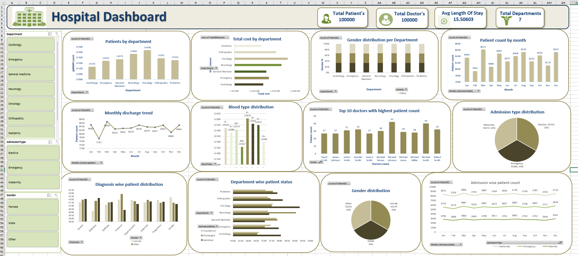

B)Microsoft Power BI Dashboard:
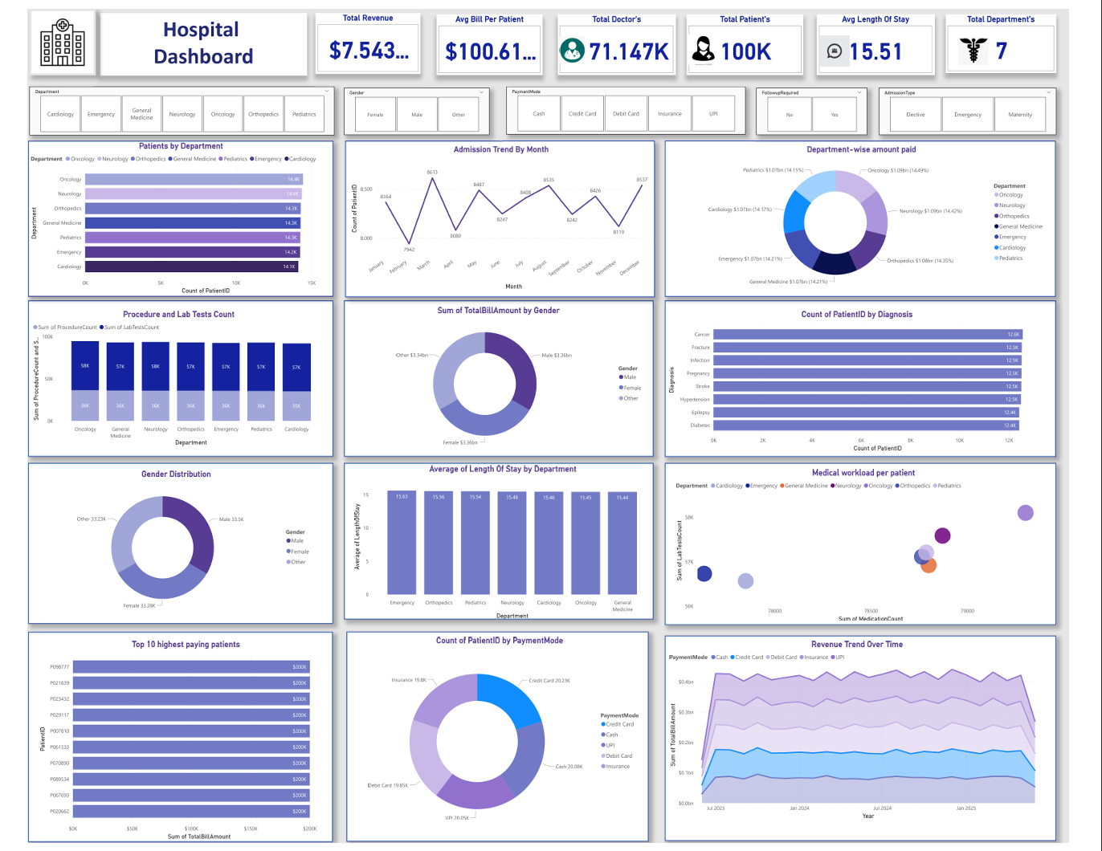

C)Tableau Public Edition Dashboard:
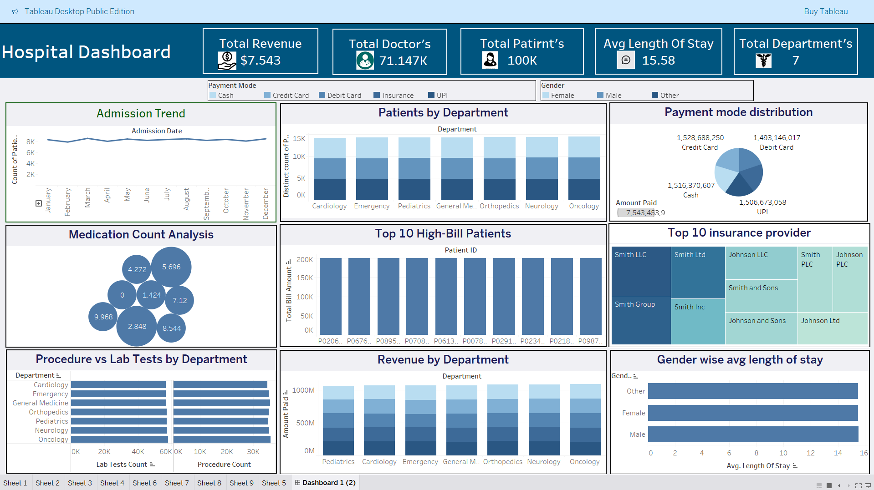

6)Challenges faced :
- Missing or incomplete data: Patient records, admission dates, or treatment costs might be incomplete.
- Inconsistent formats: Dates stored as text, inconsistent units (e.g., days vs. hours for stay duration).
- Spelling variations: Department or doctor names written differently.
- Selecting the right chart types: Balancing clarity and complexity for medical data.
- Overcrowding visuals: Risk of making the dashboard too busy.
- Color coding: Choosing a palette that is both visually appealing and accessible.

7)Conclusion:
The Hospital Dashboard successfully consolidates key operational, clinical, and financial data into an interactive and visually intuitive platform. This empowers hospital administrators and medical staff to monitor KPIs, identify bottlenecks, and make data-driven decisions for improving patient care and resource utilization. The dashboard not only enhances transparency but also supports strategic planning, ultimately contributing to improved healthcare service delivery and operational efficiency.
8)Future Scope:
- Predictive Analytics Integration
- Use historical patient data to forecast admission rates, bed occupancy, and staff requirements.
- Implement predictive models for disease outbreaks or seasonal patient trends.
- Advanced Patient Outcome Tracking
- Include recovery rates, readmission probabilities, and treatment success metrics.
- Integrate post-discharge follow-up data for better care planning.
- Financial Performance Analysis
- Add cost vs. revenue analysis per department.
- Identify high-cost treatments and potential cost-optimization areas.
- Real-time Data Streaming
- Connect live hospital systems to monitor patient admissions, emergencies, and resource availability instantly.
- Resource Optimization
- Track equipment usage, maintenance schedules, and staff workload for operational efficiency.

